II. LITERATURE REVIEW
This section reviews the methodologies adopted in recent studies related to software architecture quality and modularity, with a focus on how researchers evaluate maintainability, architectural smells, technical debt, and remodularisation. To provide a structured and comparative lens, this review draws upon the logic of the research onion by examining research strategy, time horizon, method choice, and evaluation procedures used to validate architecture-related hypotheses [1], [9].
Across the reviewed studies, a broadly positivist stance is evident, prioritising objective, measurable outcomes derived from software artefacts, repository history, and static analysis outputs rather than subjective judgement [1], [3], [6]. Most studies follow a deductive approach by testing expectations such as whether architectural smells relate to maintainability evidence, whether co-change behaviour aligns with architectural issues, or whether modularity can be captured through measurable metrics [3], [7], [8], [11]. The dominant strategy is empirical and observational, using smell detection pipelines, version history mining, and repeated measurement across releases, alongside supporting evidence synthesis from mapping studies and systematic literature reviews [1], [6], [9]. These methodological patterns align with cross-sectional evaluation and version-based measurement, where data is analysed at a single stage or across multiple releases to observe trends [6].
All sources in this review are academic publications, including peer-reviewed journal articles and peer-reviewed conference proceedings [1]–[12]. Non-academic material such as vendor documentation or practitioner blog posts may be useful for implementation guidance, but was not used as primary evidence here because it typically lacks clearly defined variables, reproducible evaluation, and peer-reviewed validation.

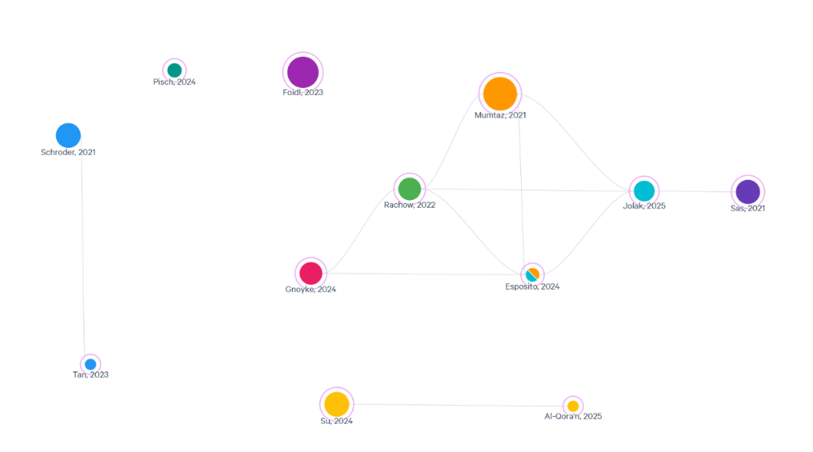
Fig. 2. Literature Map.
A literature map was constructed in Litmaps to visualise citation links between the selected academic sources [1]–[12]. Papers were grouped by concepts including smell detection and taxonomy, technical debt framing, maintainability impact evidence, smell evolution, co-change coupling, modularity metrics, modular monolith positioning, remodularisation approaches, and data pipeline quality.
Labelled relationships (conceptual legend for Fig. 2):
- Smell detection/taxonomy Maintainability impact evidence: enables measurement of smells used in maintainability evaluation [1], [3], [11].
- Technical debt (architecture) Maintainability impact evidence: frames smells as long-term cost affecting maintainability [2], [3].
- Smell evolution (versions) Maintainability impact evidence: shows how smells accumulate across versions and relate to maintainability risk [6], [3].
- Co-change/change coupling Architectural smells: links change coupling behaviour to smell presence and architectural issues [7].
- Modularity metric Architecture evaluation: quantifies modular structure for comparative analysis [8].
- Remodularisation Modularity metric: evaluates restructuring outcomes using modularity measures and effort considerations [12], [4], [8].
- Modular monolith (review/trend) Architecture evaluation: positions modular monolith as a relevant approach and summarises evaluation practices [9], [10].
- Data pipeline quality > Backend evaluation context: adds operational reliability and processing quality context relevant to ingestion-based systems [5].

A. Methodologies of Similar Studies
[1] conducts a systematic mapping study on architectural smell detection. The authors classify prior research by detection approaches, data sources, tool support, and evaluation practices. This methodology is useful for positioning because it highlights that smell detection is widely studied, but that approaches and validation methods vary across the field. The strength of [1] is the structured synthesis and clear overview of methodological trends. A limitation is that mapping studies do not directly test outcomes such as maintainability improvement, so they provide guidance on research direction rather than direct evidence for causal claims.
[3] provides an empirical investigation into how architectural smells relate to software maintainability. The methodology uses quantitative measurement, where smells are detected and then compared against maintainability-related evidence using statistical analysis. A key strength is the use of measurable variables and a repeatable pipeline. A limitation is that repository-based empirical work commonly reports associations, so maintainability differences may correlate with smells while still being influenced by other project factors.
[6] studies evolution patterns of software-architecture smells across intra- and inter-version settings. The authors use repeated measurement across many releases, which allows trends in smell appearance, persistence, and growth to be identified. This strengthens the reliability of findings compared to single snapshot studies. However, multiple factors change between versions, such as new features and refactoring, so the method is stronger for understanding evolution patterns than for proving direct cause-and-effect.
[7] explores the relationship between co-changes and architectural smells. The methodology mines version history to examine whether code entities that change together are associated with smell presence. This is relevant because frequent co-change can indicate coupling and increased maintenance effort. The strength is that it is grounded in real maintenance behaviour. The limitation is that co-change patterns can be affected by team workflow and commit practices, which may reduce internal validity if not controlled.
[8] proposes M-score, an empirically derived modularity metric. Unlike smell studies, the focus is on improving measurement quality for modular structure. This is methodologically important for architecture comparison work because modularity is often used as a dependent variable, and stronger metrics support clearer evaluation. The limitation is that modularity is multi-dimensional, so M-score should be combined with other indicators such as complexity, testability measures, and change impact evidence.
[2] introduces an architecture smell knowledge base for managing architecture technical debt. The methodology is knowledge-structuring oriented and supports decision-making by linking smells to technical debt concepts and management actions. This supports contextualisation by explaining why smells matter in practice. However, it does not provide controlled measurements of maintainability outcomes and therefore complements rather than replaces empirical evaluation.
[11] examines correlation between architectural smells and static analysis warnings. This approach strengthens evaluation through triangulation by combining architecture-level detection with independent static analysis outputs. The strength is improved construct validity. The limitation is that static warnings may vary in relevance to architecture-level quality, and correlations should be interpreted carefully.
[12] presents a search-based remodularisation case study at Adyen. The case study method provides detailed evidence in a realistic industrial context and evaluates restructuring outcomes. The strength is strong practical relevance and clear links to modularity improvement. A limitation is that findings can be system-specific and may not generalise to all domains.
[4] and [10] provide additional context. [4] proposes effort estimation for clustering-based remodularisation, contributing to how restructuring feasibility can be assessed, while [10] discusses modular monolith as an emerging trend. These sources support positioning, but provide lighter empirical evidence than journal-based studies.
Finally, [9] provides a systematic literature review of modular monolith architecture in cloud environments. This supports positioning by showing how modular monolith is defined and evaluated across studies, and highlights that methods and metrics are not fully standardised, strengthening the need for clear evaluation design in comparative work.

B. Comparisons of Studies
Across the reviewed studies, evidence synthesis papers such as [1] and [9] provide structured overviews, identifying gaps and variation in evaluation practices. In contrast, repository-based empirical studies such as [3], [6], [7], and [11] prioritise measurable indicators and tool-supported pipelines, but often provide association evidence rather than strict causal proof due to limited control over confounding variables. Case study research such as [12] provides deep contextual insight into remodularisation in practice, but can be harder to generalise across systems. These methodological differences justify the need for controlled comparative benchmarking in the current research, where requirements, dataset ingestion rules, schema, and testing conditions are kept consistent across two architecture implementations.

C. Experimental Variables Used by Other Researchers
In smell impact research, independent variables are usually smell presence, smell type, or smell intensity, while dependent variables are maintainability indicators derived from structural metrics and quality evidence [3], [6], [11]. In co-change studies, the independent variable is the co-change relationship, while dependent variables include smell presence and maintainability-related outcomes [7]. In modularity metric research, the independent variable is the modularity metric formulation, and dependent variables include modularity scores and measurement stability [8]. In remodularisation work, independent variables include the restructuring method or search strategy, while dependent variables include improvements in modular structure and effort or feasibility indicators [12], [4]. These variable choices support the structure of the current study, where architecture type is the independent variable and modularity, maintainability proxies, testability outcomes, and change impact measures are dependent variables.
D. Testing Strategies Used in Related Research
Automated smell detection pipelines with repeated extraction across versions are used in smell research, supporting repeatability but depending on tool validity [1], [3], [6]. Static analysis outputs are used for triangulation and cross-validation of quality indicators [11]. Repository mining and co-change analysis is used to test maintenance coupling using real evolution history [7]. Search-based optimisation and case study evaluation are used in remodularisation work to test whether restructuring improves modular structure, often assessed through modularity indicators and feasibility evidence [12], [4]. These strategies motivate combining structural metrics, modularity measurement, and change impact evidence for architecture comparison rather than relying on a single metric.

E. Critical Synthesis and Knowledge Gaps
The literature supports that architectural smells and technical debt are associated with maintainability risks [2], [3], [6], [11]. It also provides a range of measurement approaches, including smell detection, co-change analysis, and modularity metrics [1], [7], [8]. However, a key gap is that much empirical evidence is observational and correlational, making it difficult to isolate architectural structure as the sole cause of measured outcomes. A second gap is that modularity remains multi-dimensional, meaning a single metric cannot fully represent maintainability and testability, even when measurement quality improves [8]. A third gap is that while remodularisation case studies demonstrate practical restructuring methods [12] and effort considerations [4], there is limited controlled evidence comparing two implementations of identical requirements under identical constraints. This motivates controlled comparative benchmarking, where dataset ingestion rules, schema, API behaviour, and tests are held constant, allowing differences to be more confidently linked to architecture.

TABLE I
COMPARATIVE OVERVIEW OF STUDIES
Study | Focus | Strategy & Time Horizon | Evidence Type
[1] | Smell detection research landscape | Systematic mapping, cross-sectional | Academic synthesis
[3] | Smells and maintainability relation | Empirical study, version-based / cross-sectional | Repository metrics
[6] | Smell evolution patterns | Empirical study, multi-version measurement | Repository metrics
[7] | Co-change and smells | Empirical study, version history mining | Repository metrics
[8] | Modularity measurement (M-score) | Empirical metric derivation and evaluation | Metric validation
[9] | Modular monolith in cloud | Systematic literature review | Academic synthesis
[11] | Smells and static warnings | Empirical study, cross-sectional | Smell + static analysis
[12] | Search-based remodularisation | Industrial case study | Applied evaluation

TABLE II
RESEARCH DESIGN AND EVALUATION TOOLS
Study | Research Design | Data Collection | Evaluation Tools / Measures
[1] | Secondary research (mapping) | Study selection and classification | Taxonomies of methods, tool support, evaluation approaches
[3] | Quantitative empirical | Smell detection + system measures | Statistical analysis linking smells to maintainability evidence
[6] | Quantitative empirical (multi-version) | Smell detection across releases | Trend and persistence analysis across intra/inter-version smells
[7] | Quantitative empirical | Version history mining | Co-change analysis linked to smell presence
[8] | Quantitative metric study | Software structure data | M-score computation, stability and modularity evaluation
[9] | Secondary research (SLR) | Study selection and synthesis | Comparison of definitions, evaluation practices, and gaps
[11] | Quantitative empirical | Smell detection + static warnings | Correlation analysis between smells and static analysis warnings
[12] | Industrial case study | System data from a real organisation | Search-based remodularisation outcomes, structural improvement evidence

Recommended peer-reviewed journal articles (minimum five)
The following peer-reviewed journal articles from the reference list are recommended as core journal evidence for this topic: [1], [3], [5], [6], [7], [11].

